<https://stackoverflow.com/questions/15636047/image-in-wpf-button-not-visible-at-runtime>

Visual Studio 2022 (but should work in other versions). Add your image to a folder named as you want, in this example I created an Assets named folder. Then set the image's property to Resource in the Build Action. Then select the image in the folder and drag and then drop the into <MenuItem.Icon> and it should path properly..

[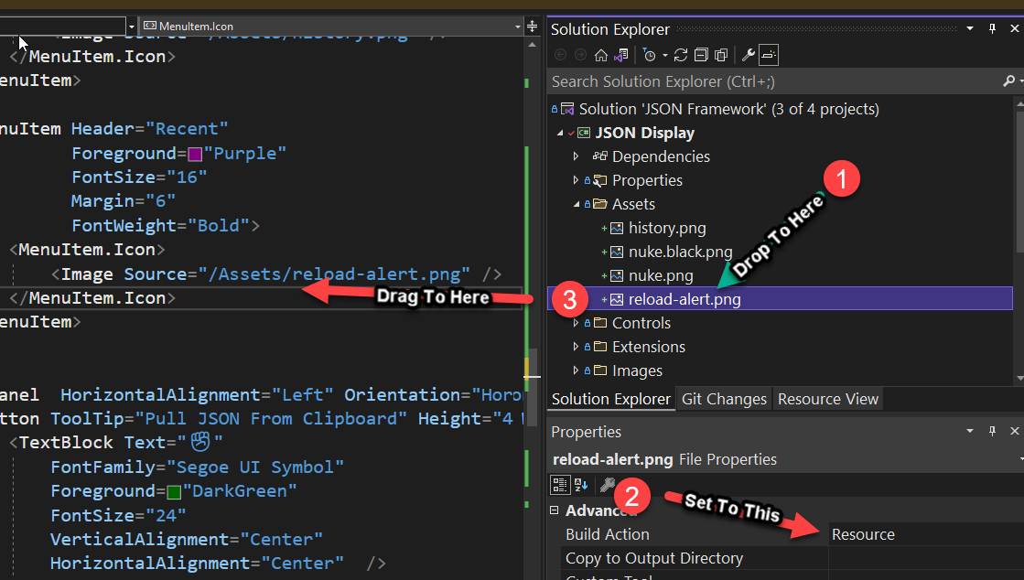](https://i.stack.imgur.com/ZScUx.png)

* Note you may need to Rebuild the project, the compiler sometimes doesn't recognize new resources as a need to rebuild.